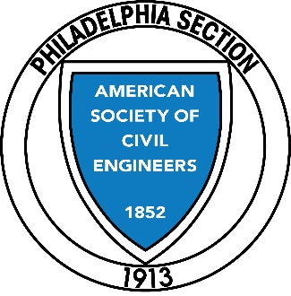
Joint Meeting with
ASCE- Philadelphia Chapter

American Society of Highway Engineers
Delaware Valley Section
1500 Walnut Street, Suite 1105, Philadelphia, PA, 19102
(215) 546-4555

Presentation:
The Delaware River Joint Toll Bridge Commission’s
Scudder Falls Bridge Replacement Project Update

Presented by Kevin M. Skeels, P.E., - Assistant Chief Engineer -DRJTBC

We anticipate that the Dinner meeting will satisfy the Pennsylvania Professional Licensing Renewal
Requirements and be good for 1 PDH. Certificates will be provided following the presentation.

When:

Where:

Cost:
Wednesday, January 15th, 2020
Social: 6:00 PM
Dinner: 6:45 PM
Meeting: 7:30 PM
Radisson Hotel Valley Forge (Radisson Building)
1160 First Avenue
King of Prussia, PA 19406

$40.00 per person (standard rate)
$50.00 per person (late fee - reservations received after Thursday, January 9th, 2020)
$20.00 per person (government employees and student rate - no late fees)
- Reservations due by Thursday, January 9, 2020.
- No refunds for cancellations after the Friday before the meeting date.

*President Alexa Egan Harper has called a meeting of the Board for 5:00PM*

Registrations can be completed using Constant Contact via the link below:

http://events.constantcontact.com/register/event?llr=t59qfm6ab&oeidk=a07egslfvxl5a8aaacb

Questions? Please contact Steve Windle (swindle@mcmahonassociates.com)

If paying by check, payment can be mailed in advance or brought to the meeting.

